DEVIKA.B
Roll no:22
MONGODB

1. Create a Mongodb Database named “Inventory”.

use Inventory

2. Create a collection named ‘Products’ and Insert the following documents.

db.Products.insertMany([
{
"_id": 1,
"name" : "xPhone",
"price" : 799,
"releaseDate": ISODate("2011-05-14"),
"spec" : {
"ram" : 4,
"screen" : 6.5,
"cpu" : 2.66
},
"color": ["white", "black"],
"storage": [64, 128, 256]
},
{
"_id": 2,
"name" : "xTablet",
"price" : 899,
"releaseDate": ISODate("2011-09-01"),
"spec" : {
"ram" : 16,
"screen" : 9.5,
"cpu" : 3.66
},
"color": ["white", "black", "purple"],
"storage": [128, 256, 512]
},
{
"_id": 3,
"name" : "SmartTablet",
"price" : 899,
"releaseDate": ISODate("2015-01-14"),
"spec" : {
"ram" : 12,
"screen" : 9.7,
"cpu" : 3.66
},
"color": ["blue"],
"storage": [16, 64, 128]
},
{
"_id": 4,
"name" : "SmartPad",
"price" : 699,
"releaseDate": ISODate("2020-05-14"),
"spec" : {
"ram" : 8,
"screen" : 9.7,
"cpu" : 1.66
},
"color": ["white", "orange", "gold", "gray"],
"storage": [128, 256, 1024]
},
{
"_id": 5,
"name" : "SmartPhone",
"price" : 599,
"releaseDate": ISODate("2022-09-14"),
"spec" : {
"ram" : 4,
"screen" : 9.7,
"cpu" : 1.66
},
"color": ["white", "orange", "gold", "gray"],
"storage": [128, 256]
}
]);

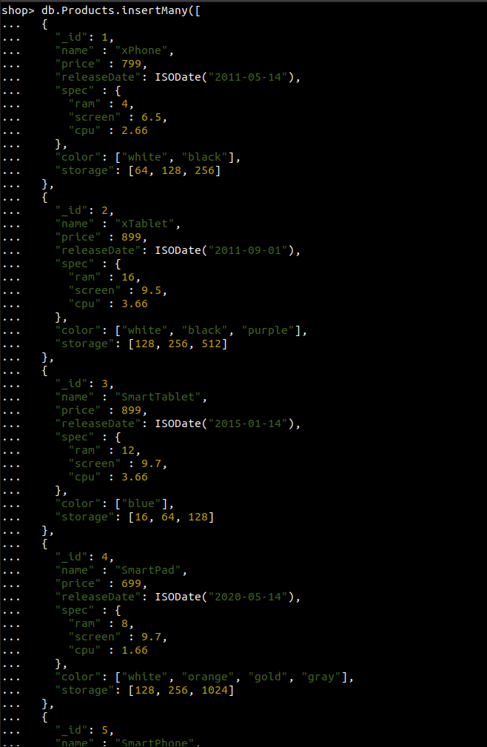

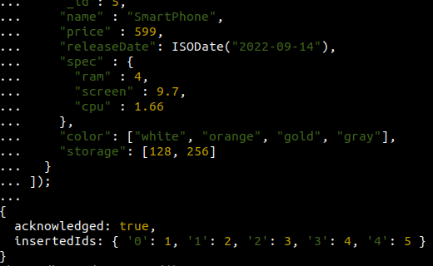

3. Display all documents in the collection product.

db.products.find()
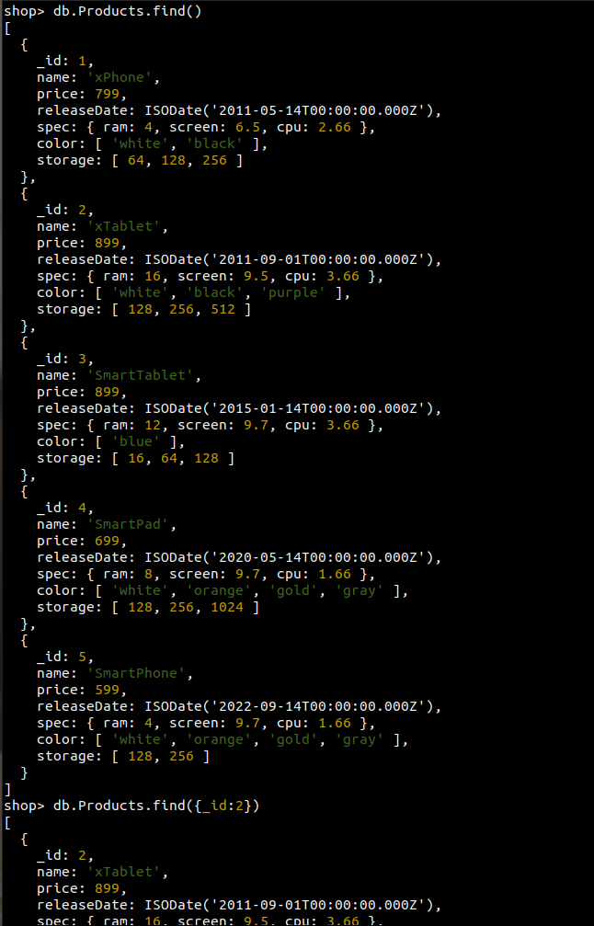

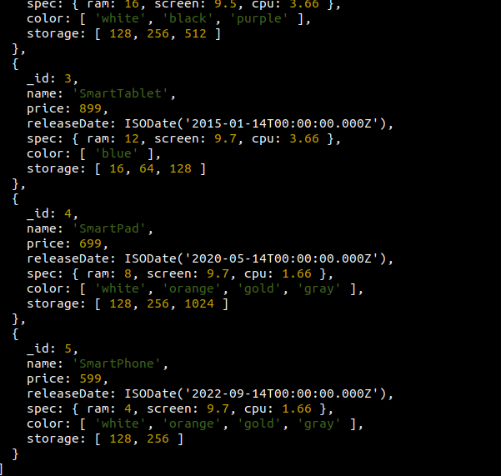

4. Display all the details of product with _ id is 2.

db.products.find({_id: 2})
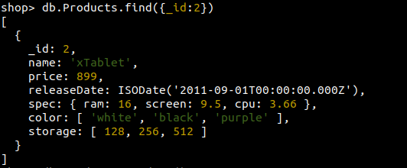

5. Display the first document in the collection product.

db.products.findone()
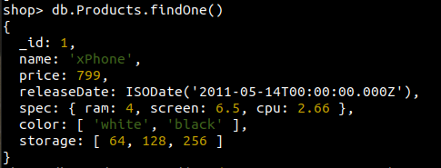

6. Display name and price of product with _ id is 5.

db.products.find({ _id: 5}, { name: 1,price: 1})

7. Query the products collection to select all documents where the value of the price field
equals 899.

db.Products.find({
price: { $eq: 899 }
}, {
name: 1,
price: 1
});

or

db.Products.find({
price: 899
}, {
name: 1,
price: 1
});
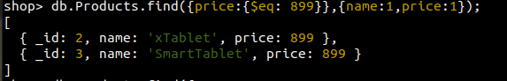

8. Search for documents where the value of the ram field in the spec document equals 4:

db.Products.find({
"spec.ram": { $eq: 4 }
}, {
name: 1,
"spec.ram": 1
});

or

db.Products.find({
"spec.ram": 4
}, {
name: 1,
"spec.ram": 1
});
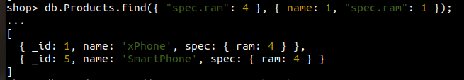

9.Query the products collection to find all documents where the array color contains an
element with the value "black":

db.Products.find({
color: { $eq: "black" }
}, {
name: 1,
color: 1
});
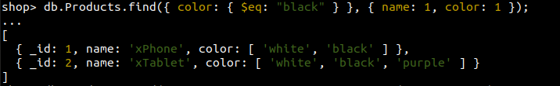

10. Select documents in the products collection with the published date is 2020-05-14:

db.Products.find({
releaseDate: { $eq: new ISODate("2020-05-14") }
}, {
name: 1,
releaseDate: 1
});

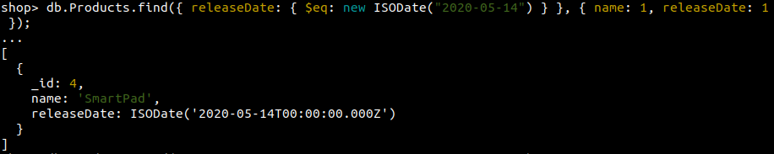

11. select documents from the products collection where price is less than 799:

db.Products.find({
price: { $lt: 799 }
}, {
name: 1,
price: 1
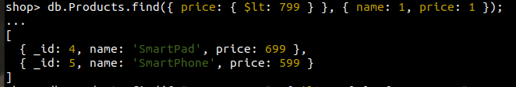
});

12. select documents where the value of the screen field in the spec document is less than 7:

db.Products.find({
"spec.screen": { $lt: 7 }
}, {
name: 1,
"spec.screen": 1
});

13. query the products collection to find all documents where the array storage has at least
one element less than 128:

db.Products.find({
storage: { $lt: 128 }
}, {
name: 1,
storage: 1
});
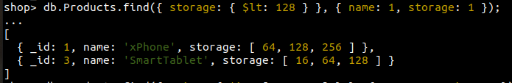

14. Display documents from the products collection whose the price is either 599 or 799:

db.Products.find({
price: { $in: [599, 799] }
}, {
name: 1,
price: 1
});

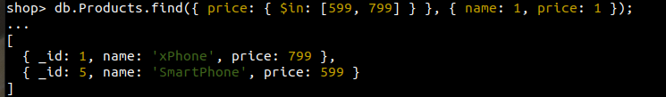

15. Display documents where the color array has at least one element
either "black" or "white":

db.Products.find({
color: { $in: ["black", "white"] }
}, {
name: 1,
color: 1
});

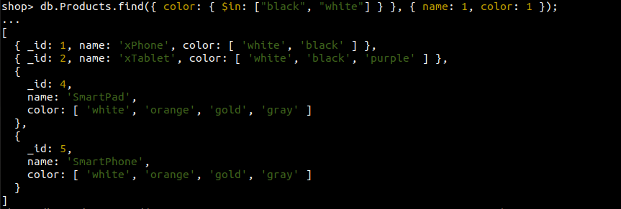

16. Display documents from the products collection whose price is neither 599 or 799:

db.Products.find({
price: { $nin: [599, 799] }
}, {
name: 1,
price: 1
});

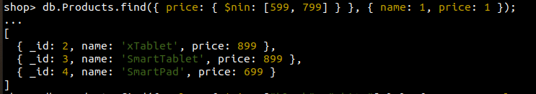

17. Display documents where the color array doesn’t have an element that
either "black" or "white":

db.Products.find({
color: { $nin: ["black", "white"] }
}, {
name: 1,
color: 1
});

18. Display all documents in the products collection where the value in the price field is equal
to 899 and the value in the color field is either "white" or "black"

db.Products.find({
$and: [
{ price: 899 },
{ color: { $in: ["white", "black"] } }
]
}, {
name: 1,
price: 1,
color: 1
});
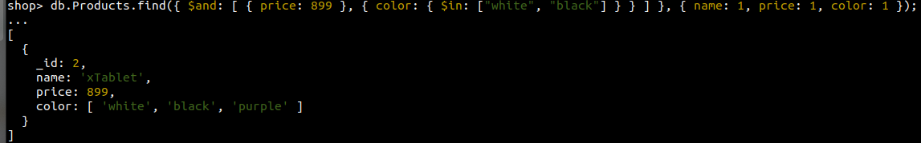

19. Select all documents where the price is less than 699 or greater than 799:

db.Products.find({
$or: [
{ price: { $lt: 699 } },
{ price: { $gt: 799 } }
]
}, {
name: 1,
price: 1
});

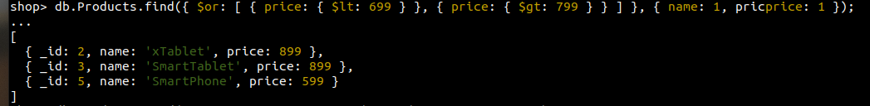

Sorting Documents
Use the sort() method to sort the documents by one or more fields. Specify { field: 1 }
to sort documents by the field in ascending order and { field: -1 } to sort documents by
the field in descending order. Use the dot notation { "embeddedDoc.field" : 1 } to sort
the documents by the field in the embedded documents (embeddedDoc).

20. Sorts the products by the values in the ram field in the spec embedded documents. It
includes the _id, name, and spec fields in the matching documents.

db.Products.find({}, {
name: 1,
spec: 1
}).sort({
"spec.ram": 1
});

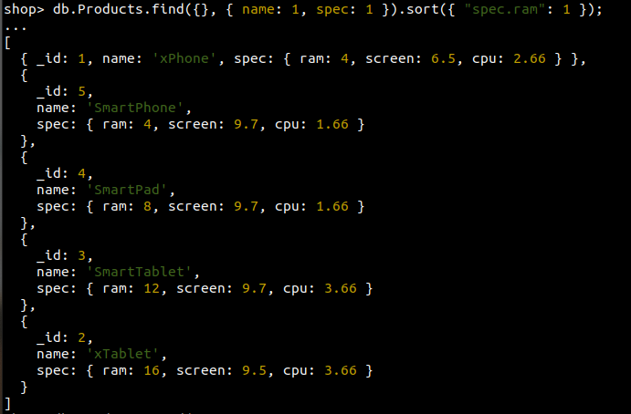

21. Sorts the products by the values in the releaseDate field in descending order:

db.Products.find({
releaseDate: { $exists: 1 }
}, {
name: 1,
releaseDate: 1
}).sort({
releaseDate: -1
});

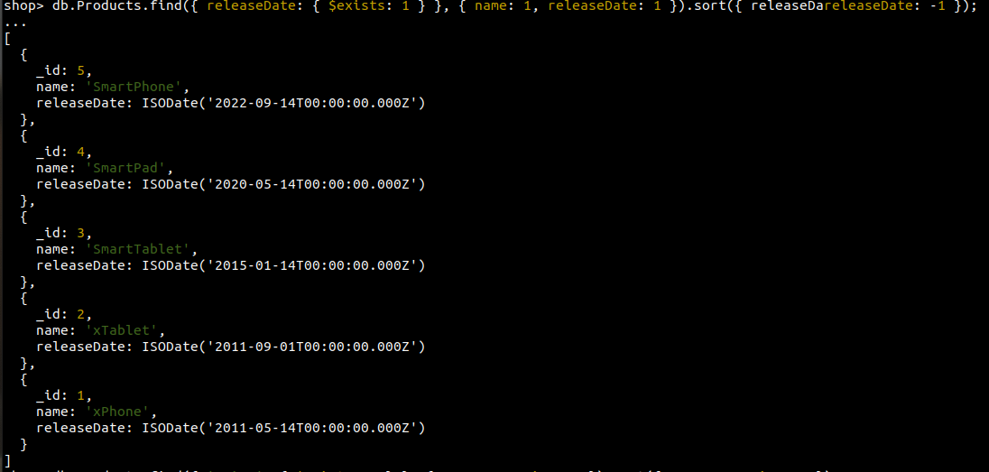

22. Sort the products by name and price in ascending order. It selects only documents where
the price field exists and includes the _id, name, and price fields in the matching
documents.

db.Products.find({
'price': { $exists: 1 }
}, { name: 1, price: 1 })
.sort({
name: 1,
price: 1
});

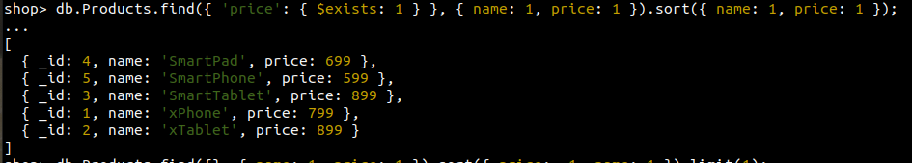

23. Get the most expensive product in the products collection. It includes the _id, name,
and price fields in the returned documents:

db.Products.find({}, {
name: 1,
price: 1
}).sort({
price: -1,
name: 1
}).limit(1);

